Internal press release!

Our Clubhouse to be!

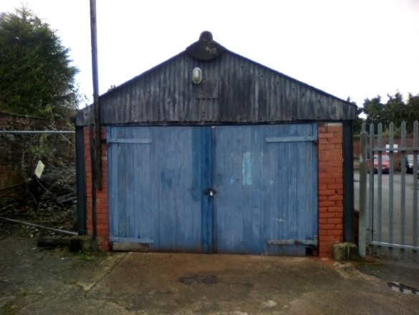

**From this to this!**

We are delighted to advise you that in late August, we received planning permission to demolish the workshop adjacent to our tennis courts and replace with a modular building. Accompanied by this at the Town Council meeting last week was a £5,000 grant and confirmation of our ownership of the building, so a good two weeks for us!

That we have now raised over 70k is a fantastic achievement for our small tennis club, but there is more to do, so please do not think we can all sit back and watch it happen by itself.

We still need a further 30k to raise, so I am in the process of writing a bid to Sport England to the Movement Fund in addition to others, and we of course as a club need to continue our fundraising.

**If you would like to help fundraise and reduce the gap, and have an idea, but need some help to develop it to fruition, please talk to Blake, our parent group or me, and we will be delighted to work with you to help deliver it!**

Clive Knight – Chairman and Trustee