 Oswestry Team Tennis


www.oswestryteamtennis.co.uk
NEWSLETTER No 16 – CHRISTMAS 2021
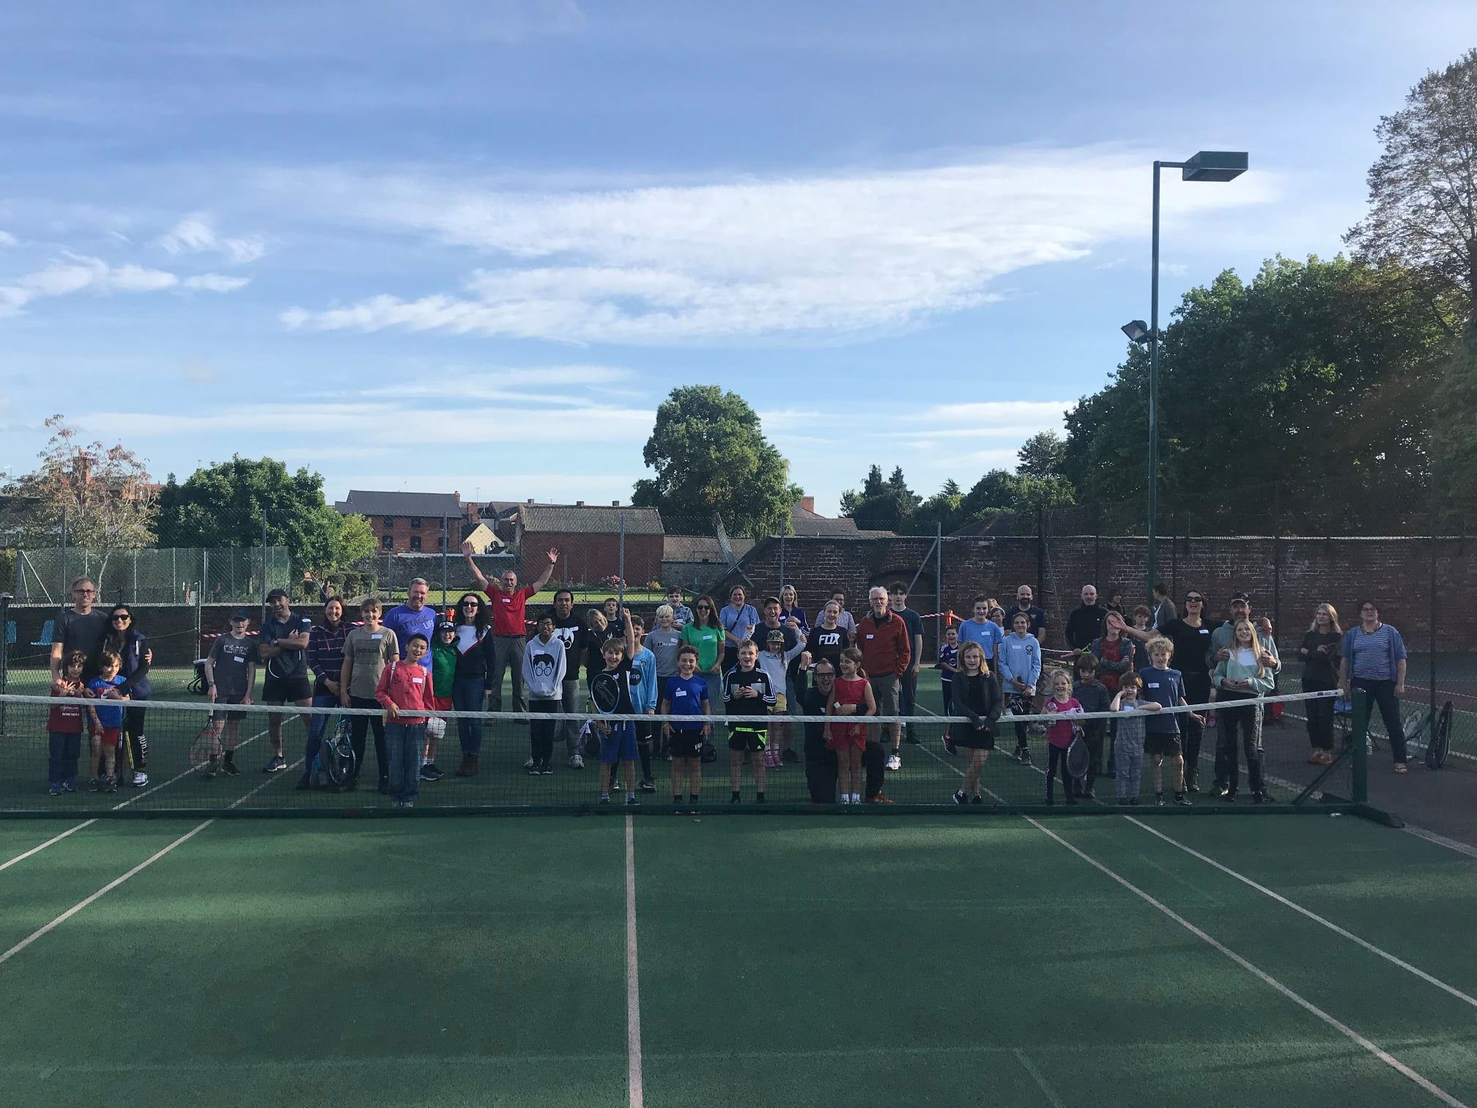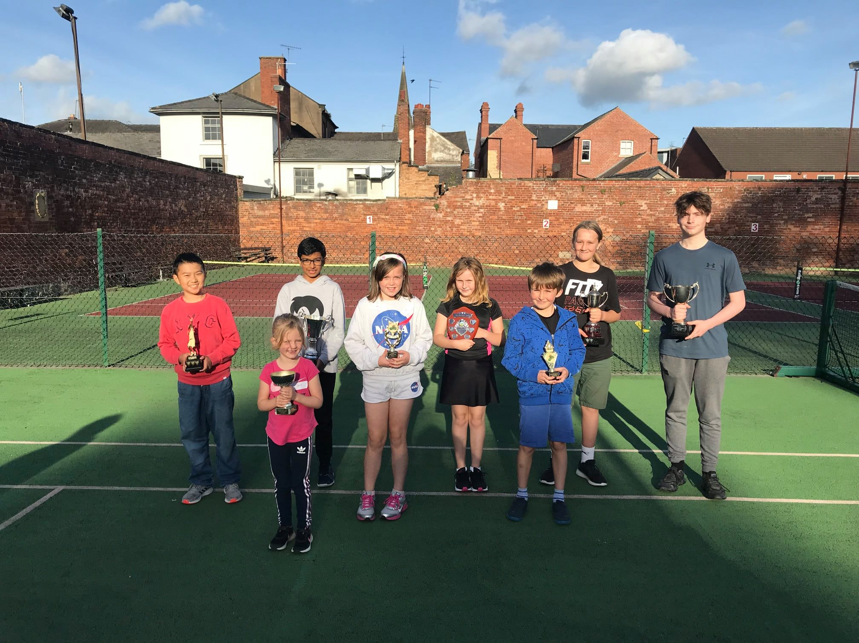
Club Celebration Day – Sunday 10th October / Our Annual Award winners
Welcome

I hope you are all okay and focusing on Christmas now that it is only three weeks away.

If this is your first newsletter, then you have a very warm WELCOME TO OSWESTRY TEAM TENNIS. I do hope you and your child enjoy being a member and having the amazing opportunity to play and enjoy tennis at such an early age.

Unfortunately covid is still with us so I will repeat my message of last year, that please please, do not overlook the need to continue follow our covid 19 guidelines whether on or off court. They are there for your safety and it is vital that you all follow them.

Many thanks must go yet again to Ben/ Blake and Nia who oversee our coaching and play such an important part in our club. Ben’s coaching report is shown a bit further on in the newsletter.

I will shortly be sending out our Sporting Challenge entry form for 2022 shortly. Profits from the Challenge go to our Clubhouse project! It is fun working out your predictions with the family over Christmas so please enter!

Last but not least, a big THANKYOU to all of you who have renewed your membership and many thanks to Blake for looking after this area, so I hope you will make good us of our courts and what the club offers you in 2022.
Parent Working Group
This is an important part of running our club. Our next Zoom meeting will be at the end of January. If anyone is willing to help our group move the club move forwards, particularly with our clubhouse project, please contact me asap.

Club Celebration Day- Sunday 10th October
On Sunday 10th October, we held our Annual Celebration Day and what an amazing day it was with around 80 people in attendance. The weather was also very kind! This was the first time it had been held since 2018 as rain and covid had sadly prevented us holding it in 2019 and 2020. Parents and children had many fun matches played between Team Judd and Team Strefford with Team Judd coming out on top by 76 points. Ben Judd and Blake Strefford were congratulated on putting the day together, ably supported by our Parents Group.
Gavin Porritt – DPA Design Consultant and I then took the opportunity to talk to the gathering to talk about our clubhouse project and show the drawings. (Please note the Planning be submitted shortly)
Ben Judd and Blake Strefford then awarded our long-awaited annual awards which sadly had not been possible to present in 2020.
Well done to all the 2021 winners as follows:-
Full ball Awards - Most improved younger: Luca Jenkins-Doyle, Most improved (senior): Erin Oakley, Enjoyment: Catrin Hopkins, Endeavour: Sol Morris, Commitment: Joe Williams, Achievement: Alfie Edwards, Team Spirit Samarth Kumar.
Mini Tennis Awards: Most improved girl: Ffion Pugh, Most improved boy: Jeffrey Li, Achievement joint: Lauren Winstanley and Reuben Thomas, Commitment joint Fin and Enzo Cummings, Enjoyment award – Harry Howell, Endeavour: Emmy Griffiths, Team Spirit joint: Nathaniel and Evan Smith.
A big thank you goes to everyone who attended with an impressive £400 raised on the day towards our exciting clubhouse project.
Membership 2021/22 Update
As I mentioned previously thank you to all of you who have paid up, which are well over 100 now. To those of you who have not yet got round to it, we do need you to be members to attend Ben and Blake’s coaching, so please make the payment asap, if only to stop Blake pestering you at this time of year!
OTT Christmas article from Tennis2You - Ben Judd
It doesn’t feel like that long ago, when I last spoke about winter is coming, but winter is coming, and it is time to get those extra layers on.
Despite the cold spell, everyone has been in good spirit and I would like to thank the parents/guardians for bearing through the cold, so that the kids can keep on learning and having fun. We will be working hard to create more games that keep the kids moving through these colder months and enjoying the sport.
These past few weeks, Blake and I have been working on ready positions and movement. Plenty of the children have come to grips with this and have continued to show it in every session, which is great to see. I have seen more kids understanding the serve and how to play points and even getting a few off me and my helpers.

There are so many things to learn in tennis, but it is the enjoyment, which helps you understand and get better. We see so many happy faces each week and we think that this enjoyment of the sport can carry on out of the lessons. We encourage all players to come and use the courts outside of their coaching, perhaps coming down with a family member or even someone from your group. It’s a great way to get more practice in and continuing that enjoyment beyond your 55-minute session. There is plenty of time when our courts are not being used and if you are not sure when, look at OTT’s website and you’ll find when the courts are free. Then head over to the park with your membership card and ask the park keepers to let you on. We want our courts to be filled all the time with the happy faces we see in each session.
Final thoughts
I trust that you all have a very happy Christmas and New Year, even if it cannot still be quite as you wish and I hope you all come back refreshed to enjoy the tennis and meet the undoubted challenges of 2022.
Take care and please stay safe
Clive Knight – Chairman

